HD 181234

HD 181234 is a 1.01 M☉, G5 star1. Based on 31 RV HIRES measurements obtained between 1999 and 2019, the CL survey reported a LPGP with a period of days, a minimum mass of MJup and an eccentricity of .

In the present study, in addition to the CL survey’s dataset, 95 RV CORALIE measurements obtained between 1998 and 2019 were used. DPASS and MCMC (1000 walkers and 300000 iterations) were used to fit the data. The properties found for HD 181234b reported in the CL survey were within the error bars associated with the values found in the present analysis. The fits are shown in Fig 1, and the corner plot in Fig 2, and the results summarized in Table 1.

Note that, recently, combining RV and Hipparcos/Gaia absolute astrometry data, a study performed in 20222 reported orbital parameters close to those of the CH survey for HD 181234b and were able to estimate the orbital inclination of the planet at °, and thus a true mass of MJup.

Conclusion: The properties found in the CL survey for HD 181234b are confirmed.

Figure 1: Left: fit of the HD 181234 RV with DPASS. Red - C98, green - C07, blue - C14, cyan - Hir94, purple - Hir04. The blue curve shows the best fit. Right: fit of the HD 181234 RV using MCMC. The black curve shows the best fit. The colorbar corresponds to the log-likelihood of the fits.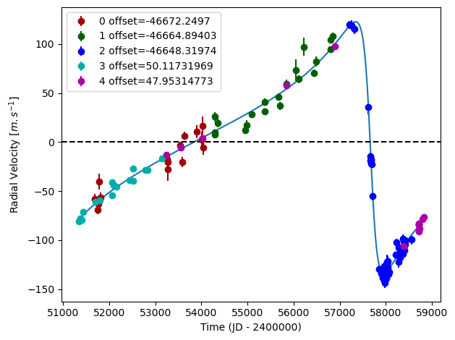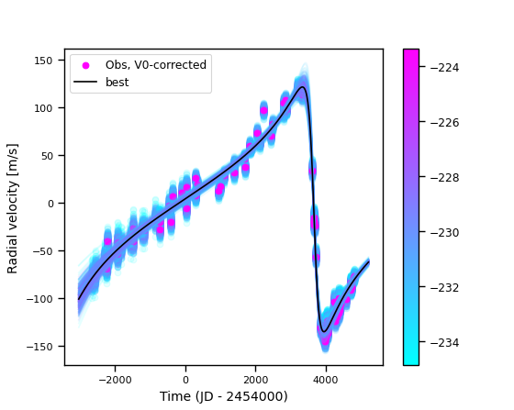

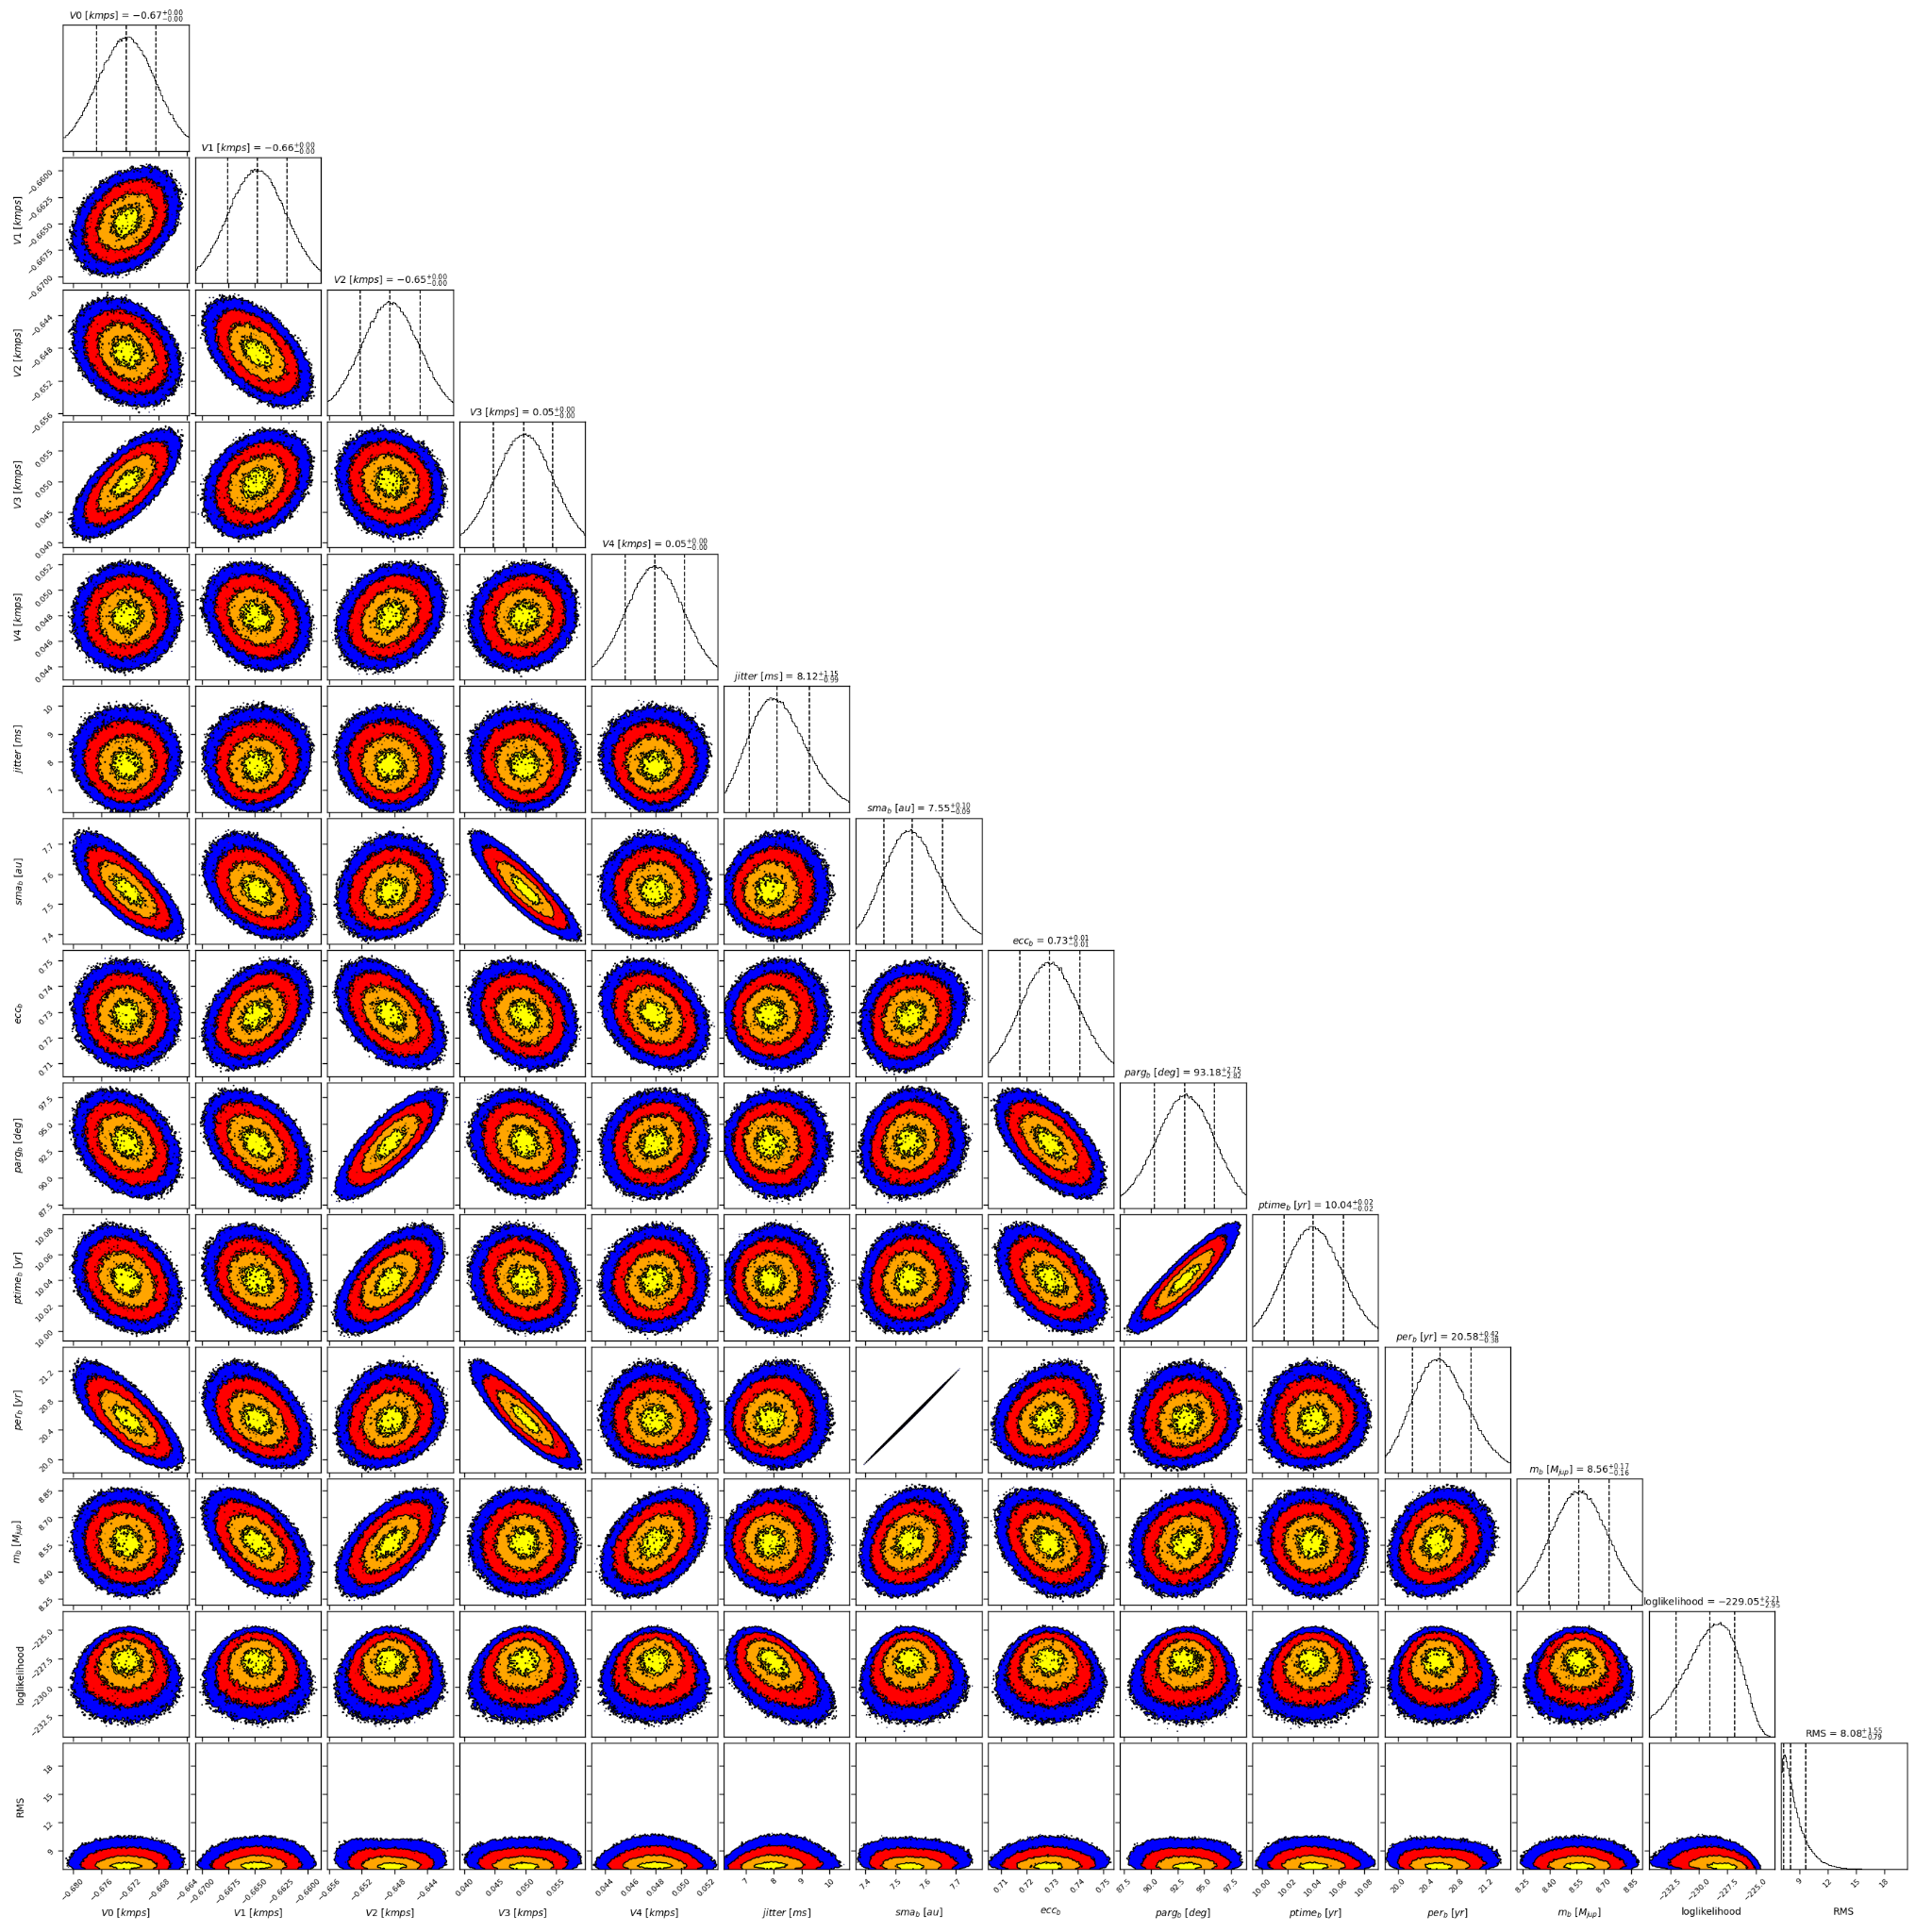

Figure 2: Corner plot of posteriors for the one-planet model MCMC fit of HD 181234 RV data.

| Parameter | Priors | | Posteriors | | CL survey |
| --- | --- | --- | --- | --- | --- |
|  | DPASS | MCMC | DPASS | MCMC |  |
| *a* (au) | [0,300] | [1,20] | 7.5 | 7.5 ± 0.1 |  |
| Msin(i) (MJup) | [0,200] | [1,20] | 8.6 |  |  |
| Eccentricity | [0,0.95] | [0.5,0.95] | 0.73 | 0.73± 0.01 |  |
| Instrumentals offsets (km/s) | [-100,100] | C98: [-47,-45]  C07: [-47,-45]  C14: [-47,-45]  Hir94: [-1,1]  Hir04: [-1,1] | C98: -46.672  C07: -46.665  C14: -46.648  Hir94: 0.050  Hir04: 0.048 | C98: -46.673 ± 0.004  C07: -  C14: -46.649 ± 0.004  Hir94: 0.050 ± 0.005  Hir04: 0.048 ± 0.002 |  |
| Stellar jitter (m/s) | [0,40] | [0,20] | 6.9 |  |  |
| Argument of periastron (°) | [0,360] | [0,360] | 93 | 93 ± 3 |  |
| Phase | [0,1] | [0,1] | 0.69 | 0.49 ± 0.01 |  |

Table 1: HD 181234. Summary of priors and posteriors obtained with DPASS and MCMC, compared to the properties reported by the CL Survey.

References

1. Rickman, E. et al. The CORALIE survey for southern extrasolar planets, XVIII. Three new massive planets and two low-mass brown dwarfs at greater than 5 AU separation. Astron. Astrophys. 625, A71 (2019).
2. Feng, F. et al. 3D Selection of 167 Substellar Companions to Nearby Stars. *Astrophys. J. Supp. Ser.* 262, 21 (2022).